**NOTE: This is an official document by Indexademics. Unless otherwise stated, this document may not be accredited to individuals or groups other than the club IDX, nor should this document be distributed, sold, or modified for personal use in any way.**

**IDX G9 Math H STUDY GUIDE ISSUE 6**

**By Samuel Wu and Grace Yu**

**Circles**

**Circle:**

* The set of all points equidistant from a given point called the **center**
* A **radius** is a segment that has one endpoint at the cneter and ther other endpoint on the circle
* **Congruent circles** has congruent radii
* a **diameter** is a segment that contains the center of a circle and has both endpoints on the circle
* A **central angle** is an angle whose vertex is the center of the circle

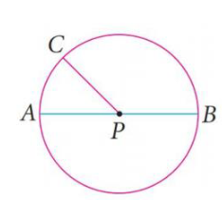

PC,PA,PB are radii, AB is a diameter, angle CPA is a central angle

**Arc:**

* An **arc** is a part of a circle
* A **semicircle** is half of a circle
* A **minor arc** is samller than a semicircle
* A **major arc** is greater than a semicircle
* **Adjacent arcs** are arcs of ther same circle that have exactly one point in common

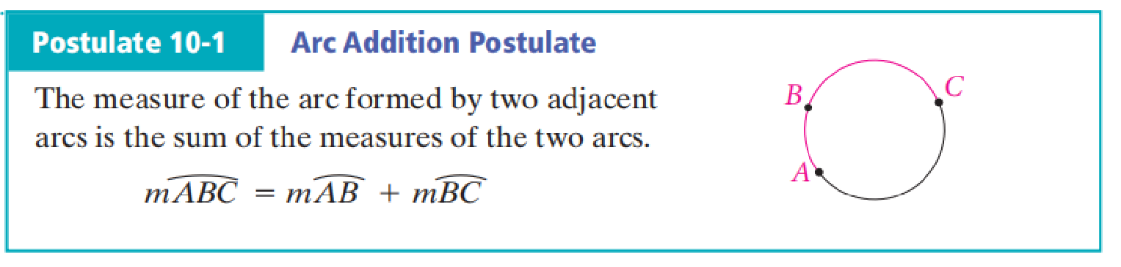

* The **circumference** of a circle is the diatance around the circle. The number **pi** is the ratio of the circumference of a circle to its diameter

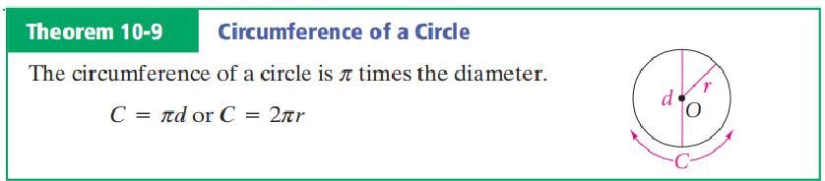

* Circles that lie in the same plane and have the same center are **concentric circles**

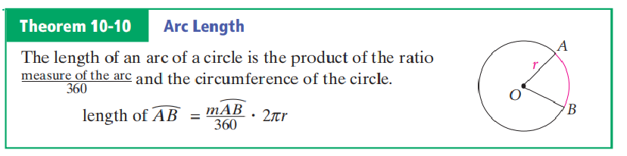

**Area of a circle:**

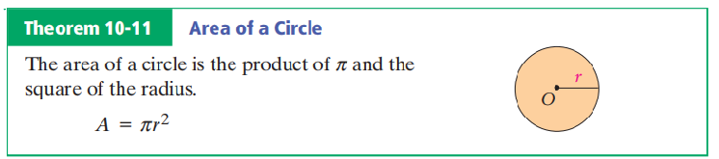

**Sector:**

* A **sector of a circle** is a region bounded by an arc of the circle and the two radii to the arc’s endpoints

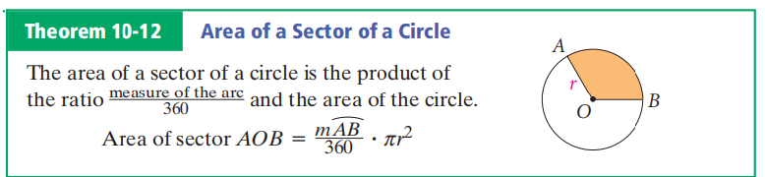

**Segment:**

* a part of a circle bounded by an arc and the segment joining its endpoint is a **segment of a circle**. To find the area of a segment for a minor arc, draw radii to form a sector. The area of the segment equals the area of the sector minus the area of the triangle formed.

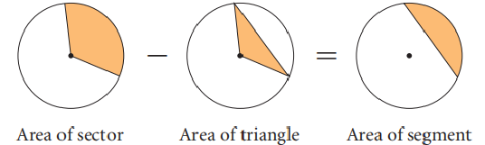

**Tangent:**

* A **tangent to a circle** is a line in the plane of the circle that intersects the circle in exactly one point
* The point where a circle and a tangent intersect is the **point of tangency**

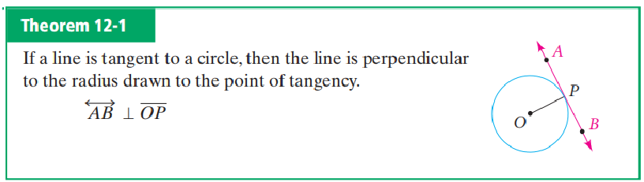

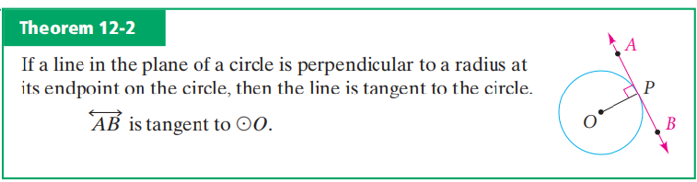

* If a circle is circumscribed about a triangle, the triangle is inscribed in the circle. Similarly, when a circle is **inscribed in** a triangle, the triangle is **circumscribed about** the circle. Each side of the triangle is **tangent** to the circle. The tangent segments from each vertex are **congruent.**

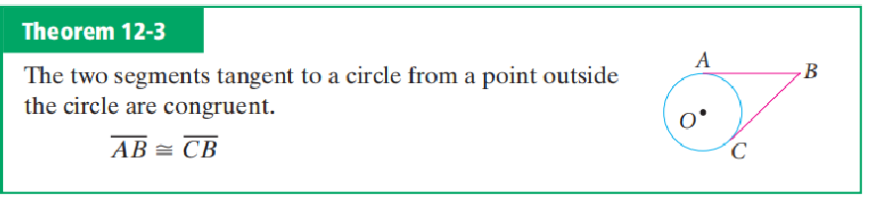

**Chord:**

* A segment whose endpoints are on a circle is called a **chord.**

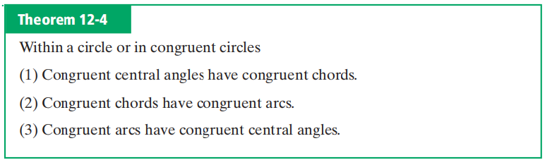

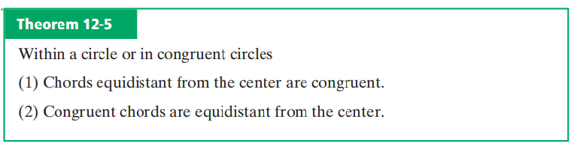

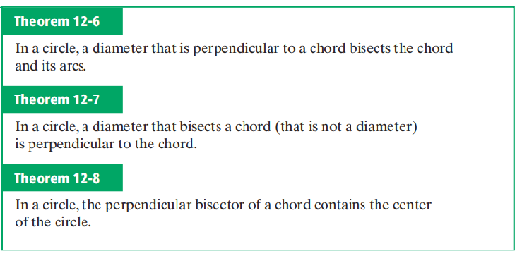

**Inscribed Angles**

* Intercepted arc / Intercepted angle definition:

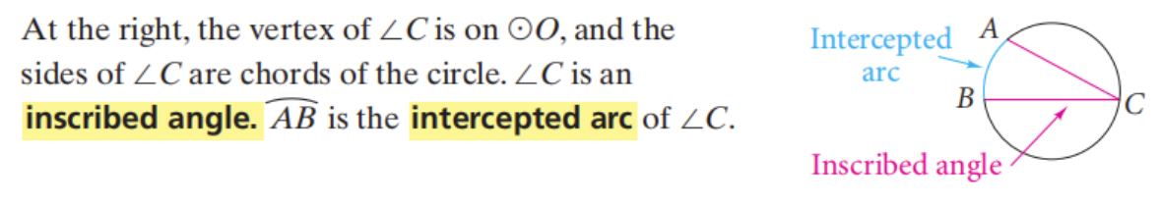

* Theorems:

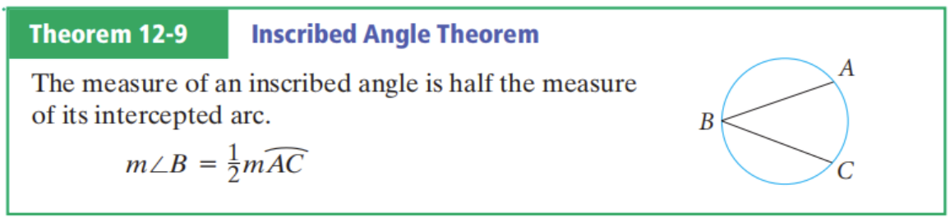

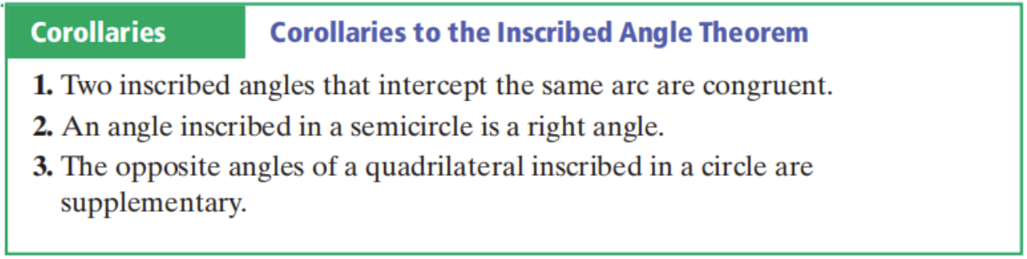

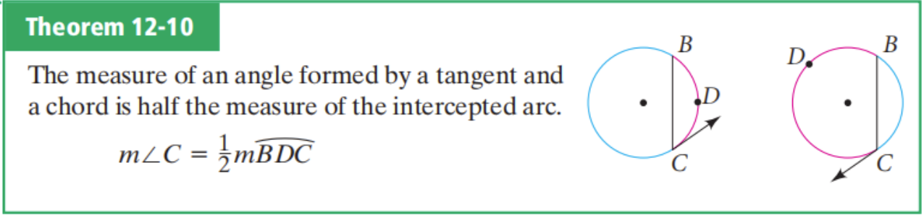

**Secant**

* Definition:

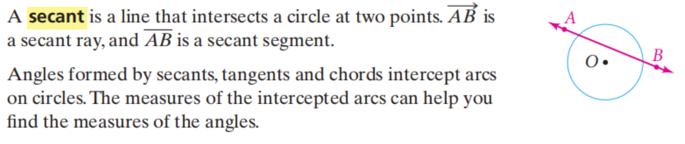

* Theorems:

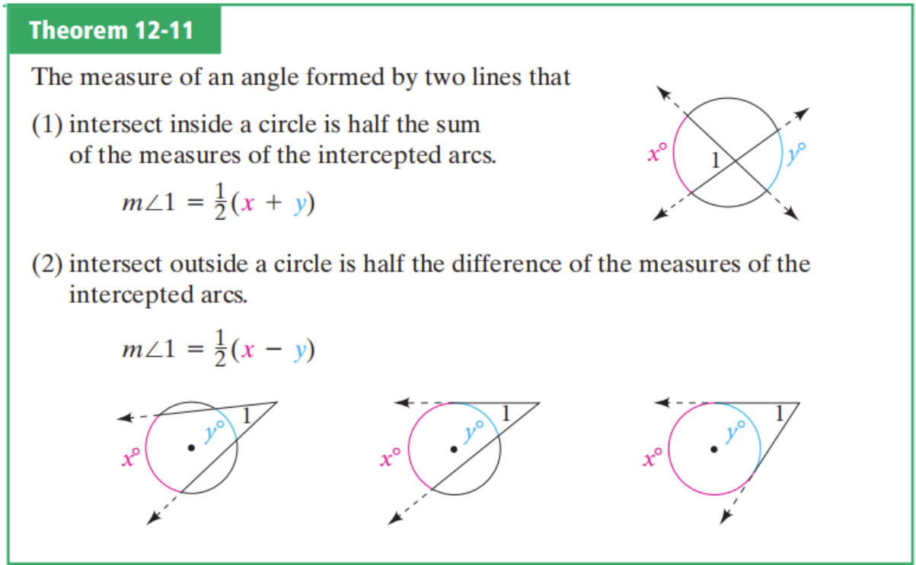

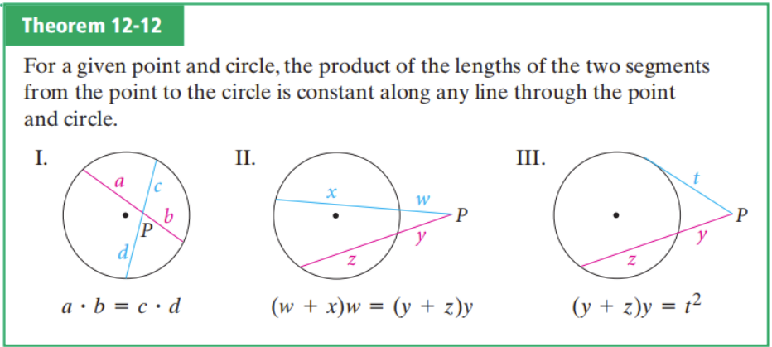

**Cyclic Quadrilaterals**

* A quadrilateral is said to be a **cyclic quadrilateral** if a circle can be drawn that passes through all four of its vertices.
* If ABCD is a cyclic quadrilateral, then **.**

⭐To determine whether four points are **concyclic or not**:

1. The opposite angles of the quadrilateral are supplementary.

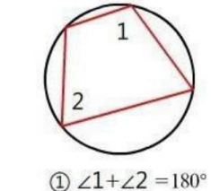

1. An exterior angle of the quadrilateral is congruent to the opposite interior angle.

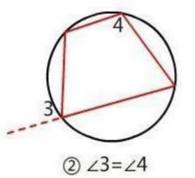

1. The top angles of two triangles with the common base are congruent.

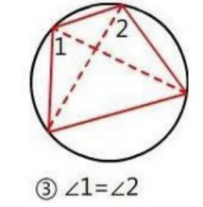

1. The four points are equidistant from a fixed point.

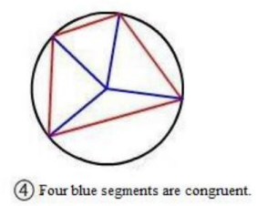

**Locus**

* Definition:



⚠️If the locus is in **SPACE**, it should be a 3-dimensional figure.

Example:

